Flynn’s website

portfollio



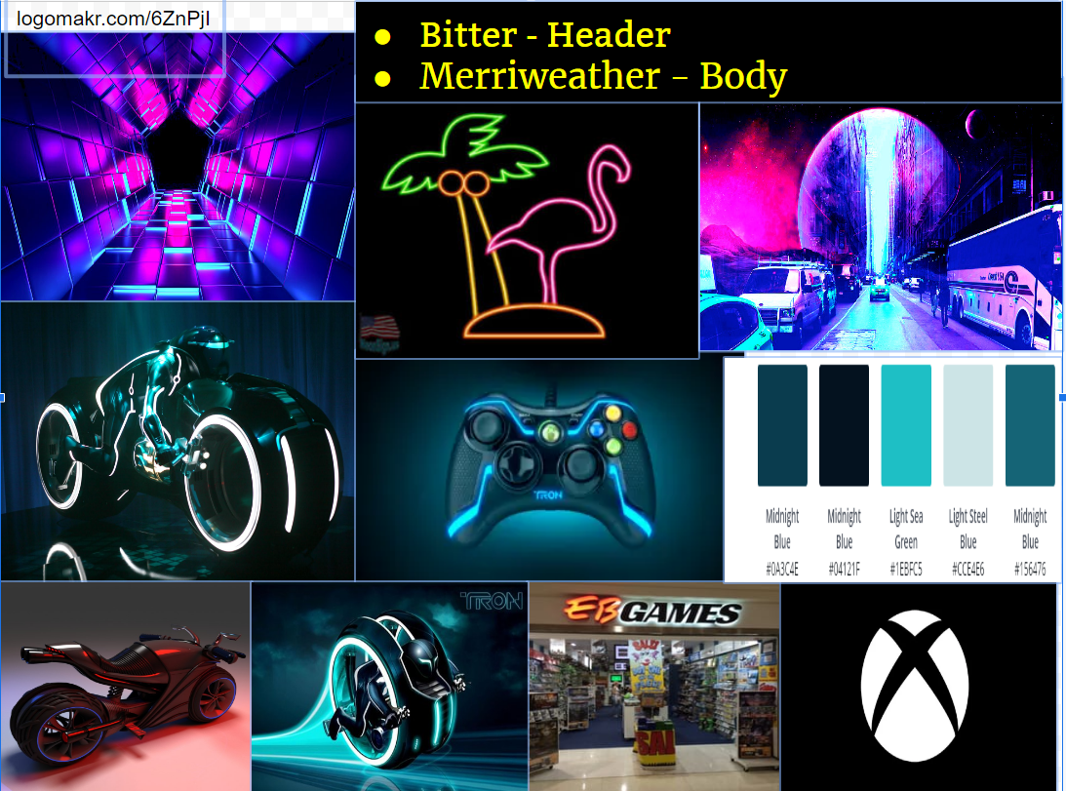

Contents

Table of Contents

Design brief………………………………………………………………. page 2

Area of instigation……………………………………………………. page 3, 4, 5

Design sketch…………………………………………………………… page 6

Final concept design………………………………………………… page 7

Design changes……………………………………………………….. page 8

Evaluation………………………………………………………………. Page 9

Bibliography…………………………………………………………… page 10

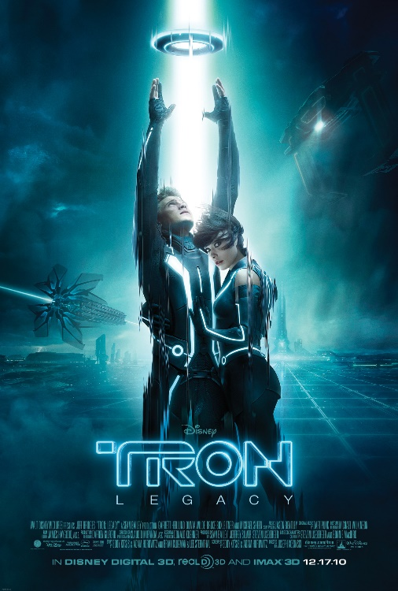

Design brief

Flynn’s Arcade is a video game arcade owned and operated by Kevin Flynn. It is a multi-story establishment, with numerous assembled arcade games on the ground floor and office space on the floor above. The upper rooms have been furnished to serve as both a work space and accommodation. Flynn’s Arcade has been slowly losing money as the trend for accessing video games has moved away from social

Video game arcades to at home and game consoles such as the Atari .Commodore. Flynn wants to

Reposition his business as a venue for selling new games and trading used games. Flynn wants you to design and

Create ‘alpha phase’ website that communicates his new business model.

Area of investigation\

Wix is an easy drag and drop creation with hundreds of templates and great tools. Wix lets you build and sell through your site. Beginner

Friendly and scalable, wix is suitable for anything from personal online portfolios to small business websites.

Weebly is one of the best and well known all in one website it has drag and drop design tools and great functionality and bundles. Weebly is a great website because builders on the market offer unparalleled ease of use and a wide array of innovative features through an extremely efficient user interface. They should provide a better way to purchase email accounts but other than that, Weebly hits the spot.

Data communications

Data communication refers to the exchange of date between a source and a receiver via form of transmission media such as a wire cable. Date communication is said to be local if communicating devices are in the same building or a similarly restricted geographical area

Datum mean the facts information statistics or the like derived by calculation or experimentation. The facts and information so gathered are processed in accordance with defined systems of procedure. Data can exist in a variety of forms such as numbers, text, bits and bytes. The Figure is an illustration of a simple data communication system.

The basic components of data communications are

* Message.
* Sender.
* Receiver.
* Medium/ communication channel.
* Encoder and decoder.

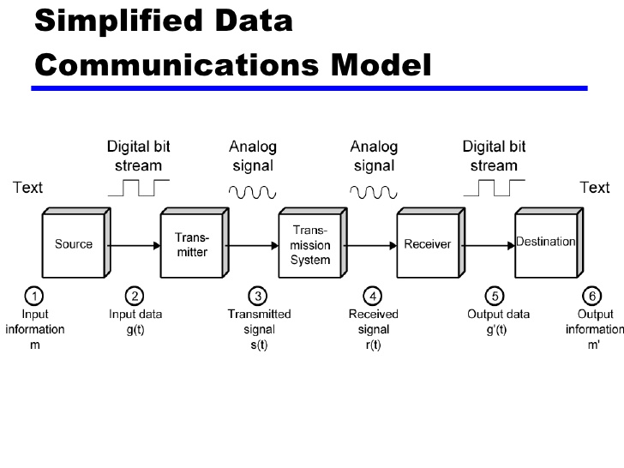

Kevin Flynn

Kevin Flynn is a great computer programmer whom, in 1982 created some of the best video games for ENCOM which included space paranoids, matrix blaster, vice squad, and light cycles. AS he developed his games, the code he wrote was stolen by fellow ENCOM programmer Ed Dillinger.

Flynn’s hometown is Paramus, New Jersey, where he was born in 1949. Flynn got his doctorate from Caltech in 1980 and got recruited by ENCOM shortly afterwards. As an upcoming young programmer, Flynn began developing new video games in secret, among which included space Paranoids, vice squad, matrix blaster, and light cycles.

Despite all of Flynn’s success and wealth his new position at ENCOM gives Flynn time in the digital world changes him deeply and he became obsessed with returning there.

Design sketch

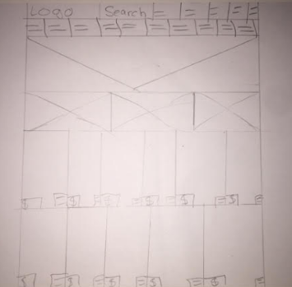

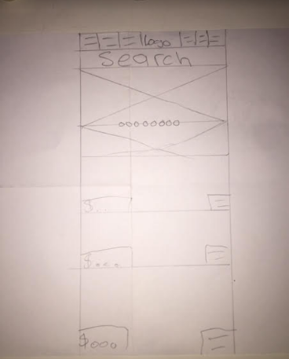This is my design sketch for my website this includes my contact page and the location of the store it also has the products and the slider and the time and date when the store is open. My sketch is inspired by jb hi fi.

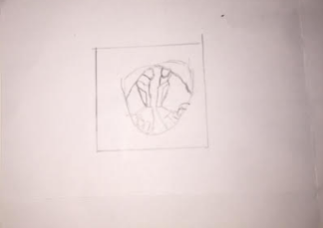For my second sketch I was designing the phone layout so if someone goes on my website on phone it would look the same just different layout so some of the features looked different due to the layout change.

When I was making a logo, I didn’t know what to make I was just thinking of anything and sir said we have to realate it to tron so on the sides I put tron but when i was making my logo I had change it because it was to hard to make so I changed it to this.

Final concept design

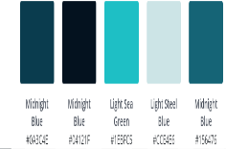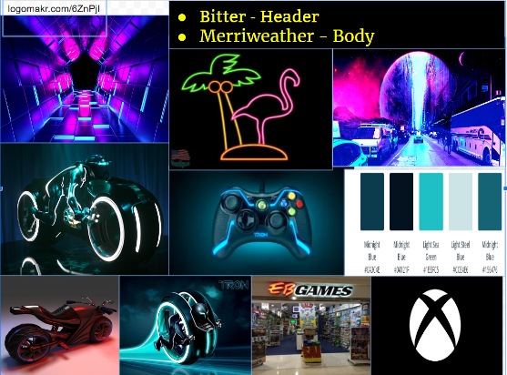 This is my colour palate I chose something with neon colours to relate to Tron because Tron is filled with neon colours and most of the colours in Tron are blue so I decided to make it mixture of different colored blues. Because not only does it suit Tron but it also suits my moot board because we had to relate our moot board with Tron and Tron is filled with a lot of neon colours so for my moot board I just put stuff that related to Tron.



My final logo compared to the logo I sketched.

Whilst I was sketching my logo, I had no idea what to do sir said relate I to Tron so I just drew guns in the middle and on the side, I just wrote Tron because I didn’t really know what to draw so I just sketched anything and tried to get ideas for my logo. My final logo now is straight forward but it looks nice and it gets the job done as it has the colures or my colour pallet.



Design changes

Some of the stuff that

I had to change were

My logos because my first one wasn’t the greatest. Some of the bad features were the skulls in my logo they took to much space and it didn’t really relate to Tron in anyway so I had to add something else in there so I added packman but that wasn’t enough to relate to Flynn’s website so I had no choice but to change it. The only good features for my first logo was that it looked nice but since it didn’t relate to Flynn’s website it didn’t matter I had no choice but to change it to something simple but good at the same time so I changed my logo to this and I’m very proud of how it turned out, compared to my last one I feel like this one just suits the Flynn’s arcade more and it’s just straight forward and nice so this is my final design for my logo.

Changing my logo didn’t really impact my final product if anything this helped more because it looked nice on all of my sliders and it suited Flynn’s website more than my first logo so it didn’t affect my product at all.

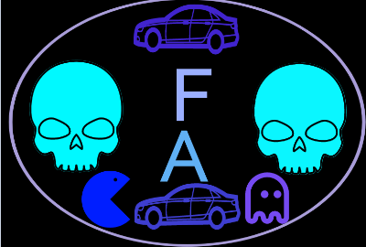

Evaluation

The following features on my website are the products and the 4 customized sliders.

The products on my website look very nice I love all the features and all the different colours it makes my website look professional, the games featured on all my products are very well known and very fun so that’s why I chose them because I’m trying to make my website look professional so it could catch people eyes.

I wouldn’t say there are any bad features to my products because in my opinion my products are very nice and there’s nothing wrong with them so I’m happy with how it turned out. The things I would want to improve for my products would be to add more colours like around the borders and that’s it really.

For my sliders I’m very happy with how they turned out I really like all the features and how it looks. And I also like how I feature my logo in front of every one of them it really stands out with all the games behind it and it just looks amazing. There is no bad feature to my sliders they all look nice.

Things that I would want to improve is how on my website it looks quite pixilated and doesn’t really stand out as much as it does in this image that’s the only thing I want to improve.

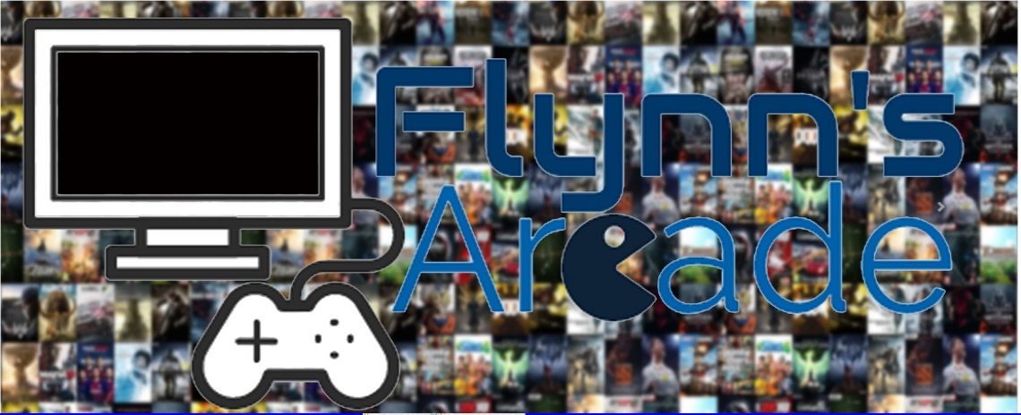

Bibliography

<https://tron.fandom.com/wiki/Kevin_Flynn>

<https://www.wix.com/website/builder?referral=split%20page#!/intro>

<https://www.weebly.com/app/website/users/127600474/sites/573895244118794011/dashboard/editor>

<https://getbootstrap.com/docs/4.3/getting-started/introduction/>

<https://www.youtube.com/watch?v=pDsta8UgWEI>

<https://notepad-plus-plus.org/downloads/>

<https://www.adobe.com/au/products/photoshop.html>

<https://www.imdb.com/title/tt1104001/>

<https://internet.com/website-building/wix-website-builder-review-fun-and-easy-to-use/>

<https://www.bluecorona.com/blog/are-weebly-websites-good-for-seo/>

<https://docs.google.com/drawings/d/1pMz640DisPCkHzdTi85Hous1IvGuczG60mNxhPTrRlk/edit>